Windows 10 Set up

Setups:

Right mouse click on Start button:

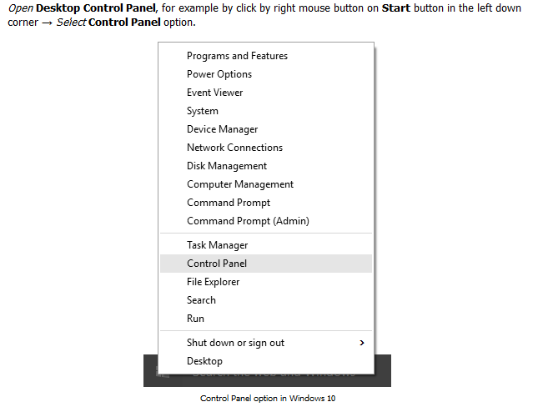

**Disable key logger**:

<http://www.pcworld.com/article/2974057/windows/how-to-turn-off-windows-10s-keylogger-yes-it-still-has-one.html>

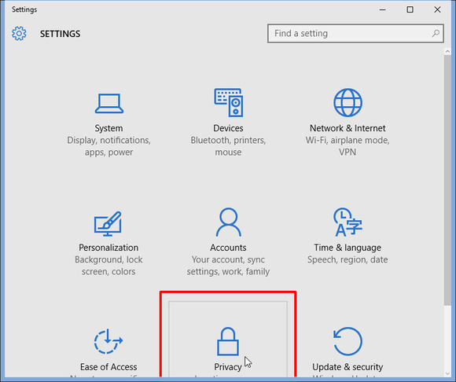

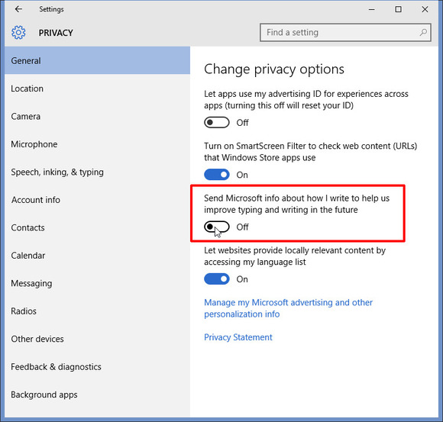

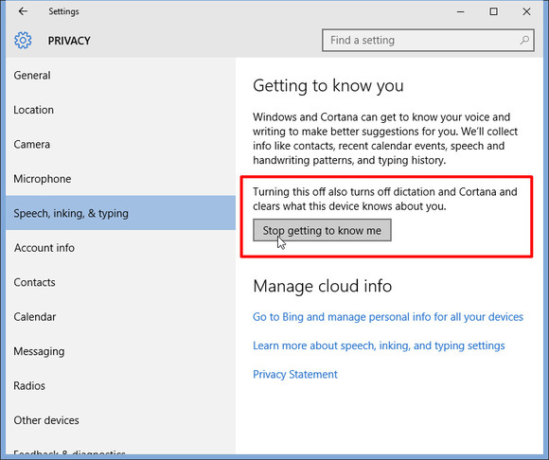

**Keep everything local**:

<http://www.pcworld.com/article/2875600/windows/windows-10-the-best-tips-tricks-and-tweaks.html#slide18>

<http://www.pcworld.com/article/2993360/windows/how-to-stop-windows-10-from-saving-files-to-onedrive.html>

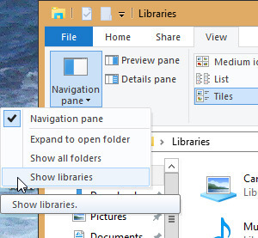

If the OneDrive process is running, you should see two Documents folders under Documents, one for OneDrive and one for local. Now move them to local.

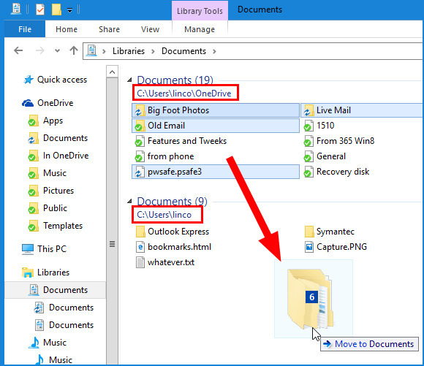

Now click the parent Documents folder with right mouse to bring up the Properties:

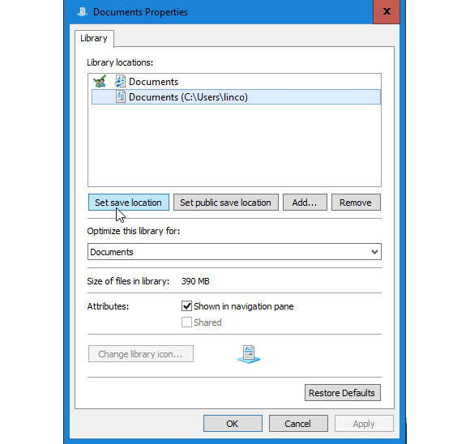

Set the locations permanently.

Keep search local:

<http://www.pcworld.com/article/2875600/windows/windows-10-the-best-tips-tricks-and-tweaks.html#slide17>

Keep login user local:

<http://www.pcworld.com/article/2975023/windows/how-to-create-a-local-account-in-windows-10.html>

Keep privacy:

<http://www.pcworld.com/article/2971725/windows/how-to-reclaim-your-privacy-in-windows-10-piece-by-piece.html>

**Startup Services:**

<http://www.pcworld.com/article/2974053/windows/your-pc-boots-gets-to-the-windows-desktop-then-freezes-now-what.html>

Windows 7, run msconfig in the command window

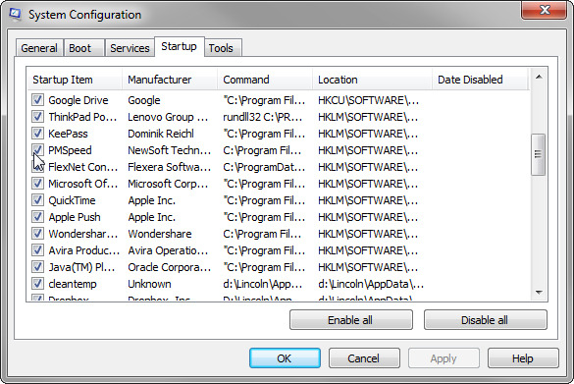

Then restart.

Windows 10, click the Startup tab in the task manager (you may click “More details” in the lower-left corner).

Boot in safe mode:

<http://www.pcworld.com/article/2984712/windows/how-to-enter-windows-10s-safe-mode.html>

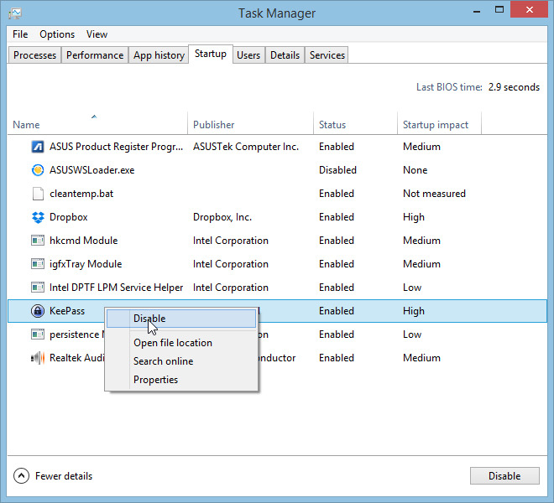

To show file extension:

http://www.file-extensions.org/article/show-and-hide-file-extensions-in-windows-10

Start Picture of the Start button , Control Panel, Appearance & Personalization, Folder Options, View tab, advance settings.

Or in Windows 10

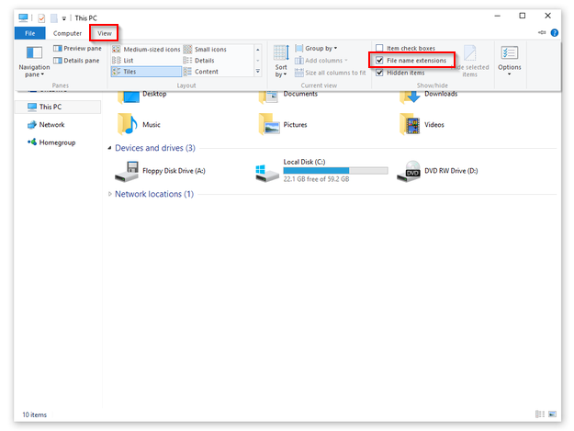

Cortana:

<http://www.pcworld.com/article/2949759/windows/killing-cortana-how-to-disable-windows-10s-info-hungry-digital-assistant.html>

<http://www.pcworld.com/article/2949828/windows/meet-cortana-the-ultimate-guide-to-windows-10s-helpful-digital-assistant.html>

Virtual Desktop:

<http://www.pcworld.com/article/2950916/windows/windows-10-review-its-familiar-its-powerful-but-the-edge-browser-falls-short.html?page=5>

from here:

<http://www.pcworld.com/article/2950916/windows/windows-10-review-its-familiar-its-powerful-but-the-edge-browser-falls-short.html>

Turn off File Explorer’s quick access view:

<http://www.pcworld.com/article/2875600/windows/windows-10-the-best-tips-tricks-and-tweaks.html#slide21>

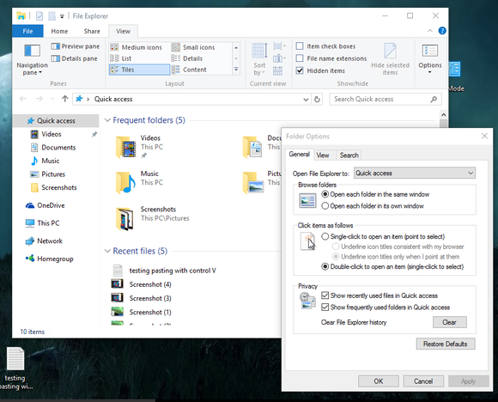

View ribbon > options > Folder Option

Schedule updates and restart:

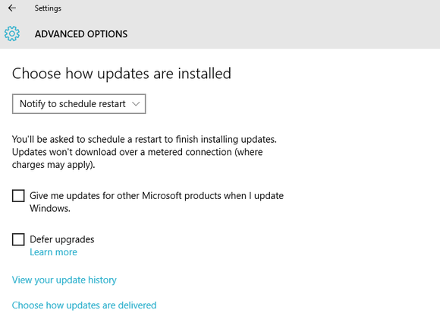

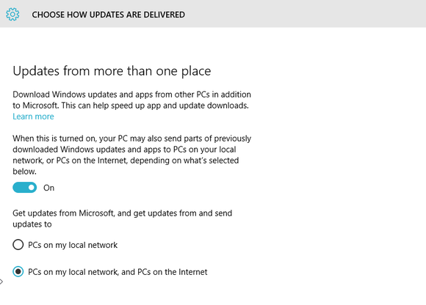

New command window:

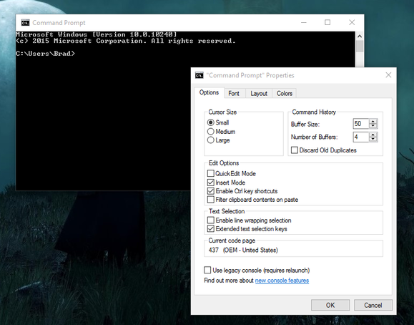

Video capture:

<http://www.pcworld.com/article/2983165/software-games/how-to-use-windows-10s-game-dvr-to-record-videos-of-your-pc-gaming.html>

Windows Key + G – saved under Video\Captures

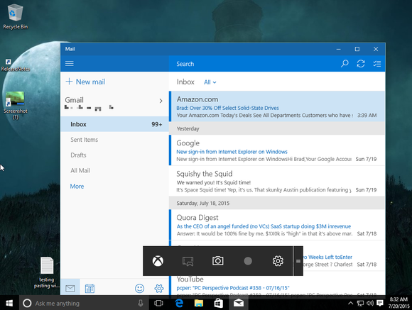

GodMode:

<http://www.pcworld.com/article/2875600/windows/windows-10-the-best-tips-tricks-and-tweaks.html#slide13>

<http://www.pcworld.com/article/2881613/unlock-windows-10s-hidden-powerful-godmode-tool.html>

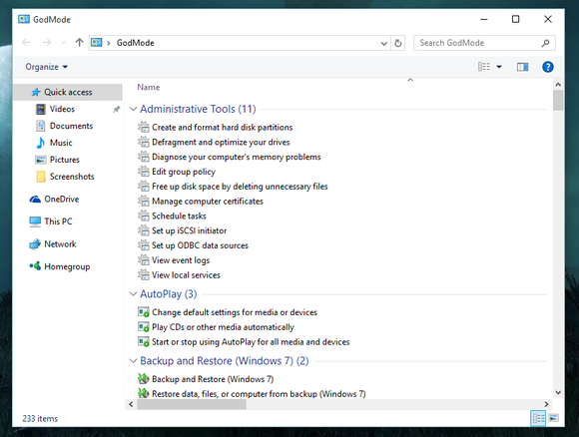

Just create a new folder and rename it to following:

GodMode.{ED7BA470-8E54-465E-825C-99712043E01C}

Create Recovery disk:

<http://www.groovypost.com/howto/create-windows-10-usb-recovery-drive/>

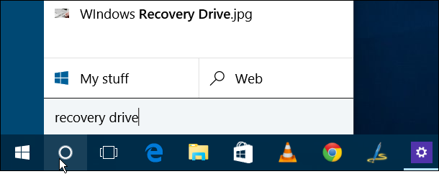

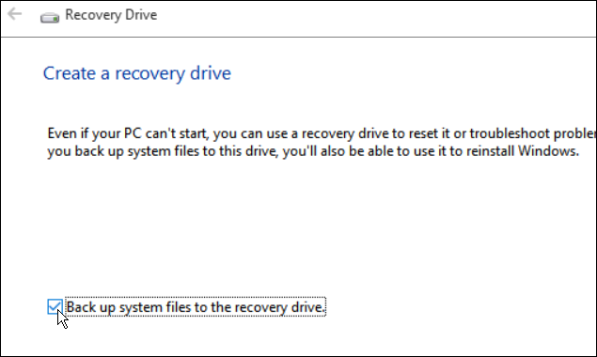

To restore, boot from the USB drive:

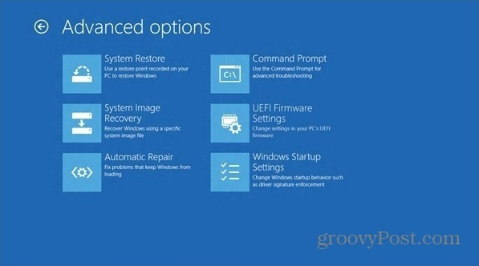

<http://www.pcworld.com/article/2052820/software/20-free-pc-apps-to-ease-daily-tasks.html#slide12>

WinMerge

Recuva – undelete

Unlocker – unlock dll files

Everything – indexer

Virtual desktop

<http://www.pcworld.com/article/2875600/windows/windows-10-the-best-tips-tricks-and-tweaks.html#slide21>

Start menu:

<http://www.pcworld.com/article/2988494/windows/11-must-know-start-menu-tricks-for-windows-10.html#slide3>

<http://www.pcworld.com/article/2960788/windows/how-to-customize-windows-10s-start-menu.html>

<http://www.pcworld.com/article/2988982/windows/how-to-save-specific-windows-file-explorer-searches-for-fast-future-queries.html>

<http://www.pcworld.com/article/2975931/windows/20-must-know-keyboard-shortcuts-for-windows-10.html>

Drives:

<http://www.pcworld.com/article/2991913/apple-phone/where-you-at-5-location-tricks-for-iphone-and-ipad.html>

<http://www.pcworld.com/article/3005797/software-productivity/5-cool-google-drive-features-you-probably-arent-using-yet.html>

<http://www.pcworld.com/article/2899087/maximize-your-ssds-lifespan-with-the-right-maintenance.html>

backup & restore

<http://www.howtogeek.com/131907/how-to-create-and-use-a-recovery-drive-or-system-repair-disc-in-windows-8/>

MS Office:

<http://www.pcworld.com/article/3003120/software-productivity/master-slideshow-creation-with-these-15-powerpoint-keyboard-shortcuts.html>

<http://www.pcworld.com/article/2984714/software-productivity/how-to-embed-fonts-in-word-documents-so-they-stay-even-if-you-send-the-file.html>

<http://www.pcworld.com/article/2996641/software-productivity/15-powerful-microsoft-word-shortcuts-you-need-to-know.html>

<http://www.pcworld.com/article/247302/work_faster_in_microsoft_word_10_secrets.html>

<http://www.pcworld.com/article/2995399/software-productivity/15-simple-yet-powerful-excel-functions-you-need-to-know.html>

<http://www.pcworld.com/article/2995986/software-productivity/these-15-excel-keyboard-shortcuts-will-help-you-become-a-spreadsheet-master.html>

<http://www.pcworld.com/article/3010614/software-productivity/meet-excel-2016-9-of-its-best-new-features-from-databases-to-handwriting-tools.html>

<http://www.pcworld.com/article/2975790/windows/how-to-stop-windows-10s-annoying-microsoft-office-ads.html>